**Module-3: Docker – I Assignment – 5**

**To Do :**

● Create a sample HTML file

● Use the Dockerfile from the previous task

● Replace this sample HTML file inside the docker container with the default page

**Solution :**

Sudo rm index.html

sudo nano 1.html

nano Dockerfile //ADD . /var/www/html

**// Default html file inside docker container replaced**

**Building this Dockerfile :**

Sudo docker build . –t app1 *//Image created from the Dockerfile.*

**$ sudo docker run -itd -p 85:80 *app1*** *//running* ***container*** *from the image*

*//Apache2 service started automatically.*

**Google search the Public IP : 85 (85 – port)**

[**http://3.145.107.2:85/**](http://3.145.107.2:85/1.html)

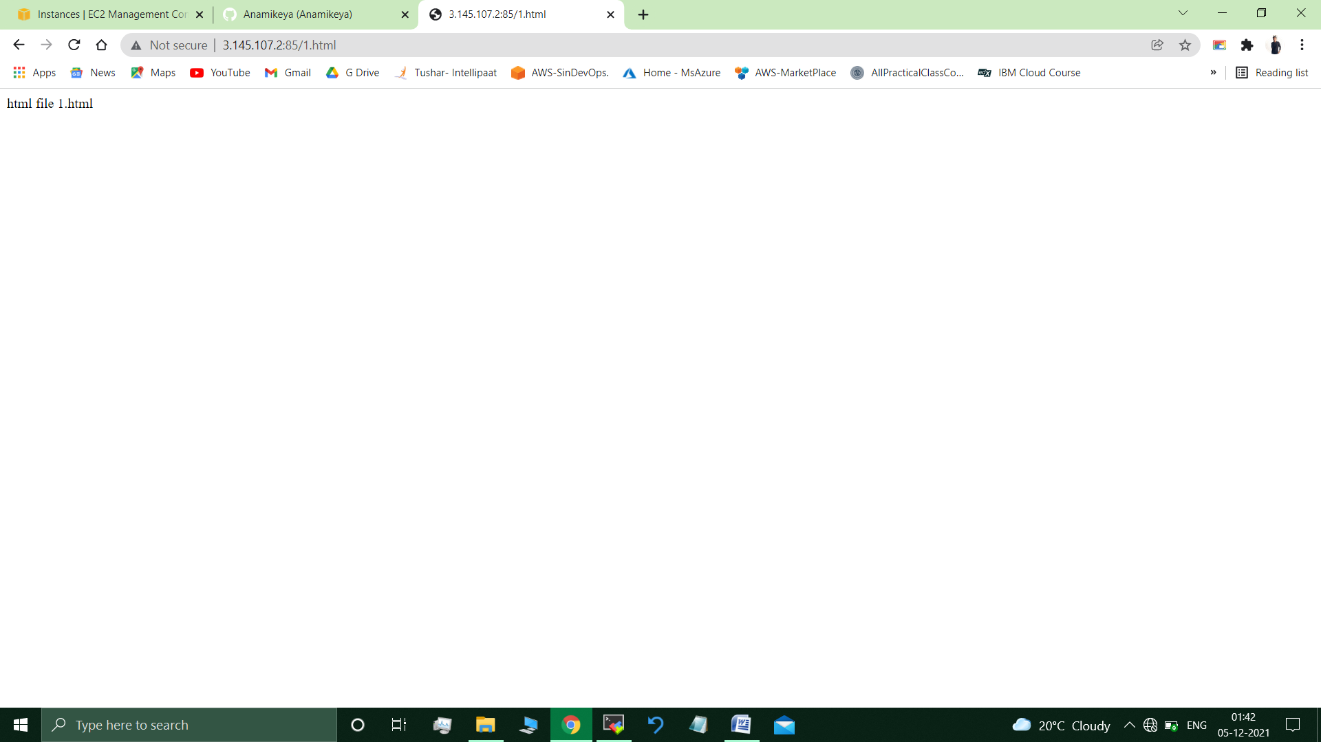

**Submitted By : Tushar Sinha**

**Email ID :** [**sinhatushar17@gmail.com**](mailto:sinhatushar17@gmail.com)

**Enrolled in the “DevOps Architect Master’s Training Program”**